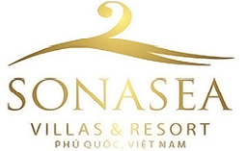

29/07/2019

Address: SS02 & SS06, Sonasea Villas & Resort, Apart. Kosmos,No.5 Duong Bao Hamlet, Duong To Commune, Phu Quoc District, Kien Giang Province

RESERVATION CONFIRMATION 019-297-F

Arrival date: 03/12/2019
Departure date: 13/12/2019
Room type: T1 – One bedroom apartment
No of guest: 02 Adults +1 Сhild
Guest’s name: TRETIAKOV YURII 12.12.1962
KORENKO OLGA 22.08.1963
KORENKO KSENIIA 16.08.1967

Check - in time: 14:00
Check - out time: 12:00

On behalf of / От лица
Grand Executive Travel Ltd.

